Explanatory report on

“**A String of Decorative Flashing Lights Using Arduino or Raspberry Pi**”

Submitted to:

**Happy Monday**

**Student ID: 202118010418**

**Group: L4C3**

A mini project submitted in partial fulfillment of the requirements for the module of

[Circuit and Digital Logic]

­

DEPARTMENT OF cOMPUTER sCIENCe

OXford brokes university and Chengdu

university of technology collaborative programme

Date: 2023/05/07



[Chengdu University of Technology]

List of Contents

1. Cover Page.................................................................................................1
2. List of Contents...........................................................................................2
3. Introduction..................................................................................................3
   1. Project Introduction ..............................................................................3
4. Project Outline………………………………………………............................3
   1. Brief Introduction………...........................,............................................3
   2. Circuit diagram and components..........................................................4
   3. Tasks….……….....................................................................................6
5. System Design............................................................................................9
   1. Purpose of the system……...................................................................9
   2. System functions..................................................................................9
   3. Circuit Design……………...................................................................10
   4. Program Design…………………………………………………………..10
6. Results…..................................................................................................12
   1. Project result.......................................................................................12
7. Conclusion and Contribution.....................................................................13
8. Reference…………………........................................................................14

# Introduction

**1.1. Project Introduction**

Using sparkly decorative lights has indeed become a popular way to add some festive flair to a residential or commercial space for celebrations or special occasions. In this project, my partner Aron and I designed and implemented an Arduino-based decorative flash string circuit that can control multiple leds to create four flash modes.

The aim of this project is not only to create beauty and atmosphere with decorative lights, but also to demonstrate our practical capabilities. By designing the functions, circuits and programs ourselves, and putting all the pieces together, we demonstrated our hands-on skills and creativity.

In general, we completed all the tasks of this project independently according to the course requirements and self-learning. Our decorative string of lights not only shows the basic flash control, but also features 4 different flash modes..

# Project outline

**2.1 Brief Introduction**

Sometimes strings of flash lights are used to decorate interiors, courtyards, public places and other Spaces that need a festive atmosphere during family gatherings, Christmas and Spring Festival. In this project, my partner Aron and I will use the Arduino Uno board and other components to design and create our own decorative flash strings. We will assemble the circuit, the programming board to control the led, and introduce the different blinking modes.

## 2.2 Circuit diagram and components

The circuit diagram of our group's Arduino-based flash is shown in the figure.

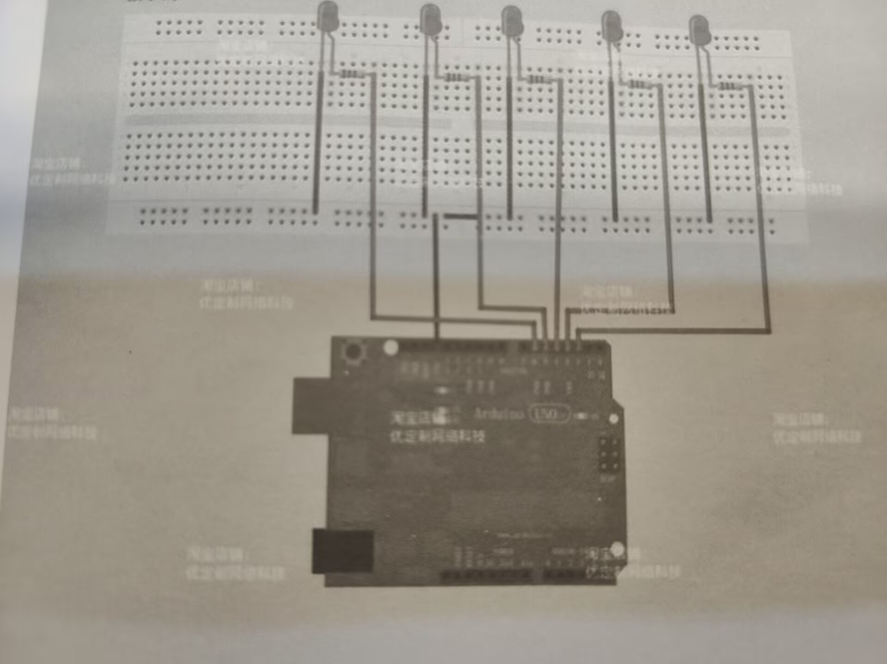

To complete this project, we will need the following components:

* Arduino Uno board: The Arduino Uno board is the main microcontroller board that I will use to control the leds. It has a built-in USB port for programming and power, which I'll connect to my computer via a USB cable. In addition, there were various input/output pins that I would use to wire to the breadboard and resistors and leds through wires [1].
* LED(5):LED is decorative light, I will use Arduino Uno board control. When a voltage is applied, they glow, and by controlling the voltage and current, I can make them flicker or flash in different patterns.
* Wires: Wires are used to connect different electronic components together, such as an led to an Arduino board or a resistor to a breadboard.
* Breadboard: Breadboard is a prototype board used to build and test circuits that do not require welding. It has a grid of porous and metal bars that allow me to connect the electronics together with jumpers to implement the circuit [1].
* Resistor: A resistor is an electronic component that limits the flow of current in a circuit. In this project, they are used to regulate circuits and protect circuits.
* Jumpers: Jumpers are short wires with connectors at both ends used to connect electronic components on breadboards or other prototype boards together [1].

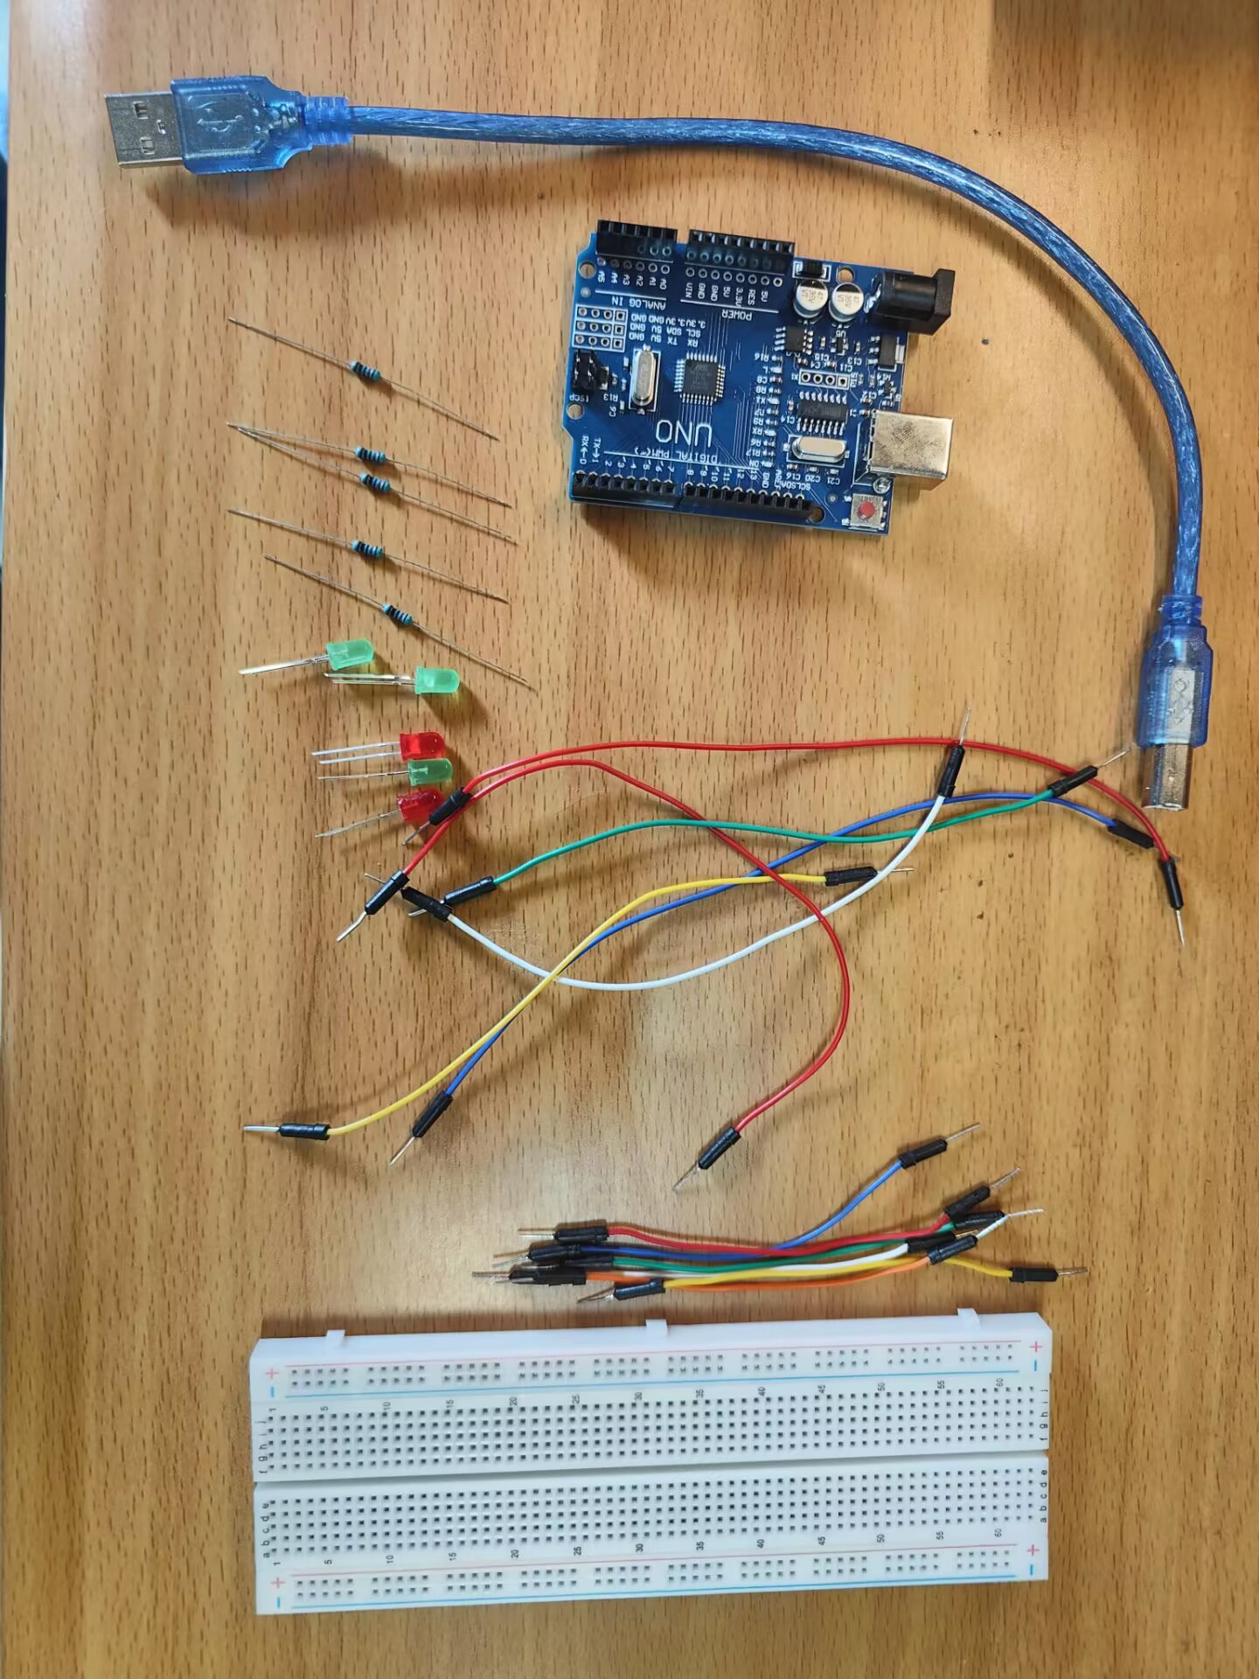

## 2.3 Tasks

**i. Assemble the circuit**

The first task is to assemble the circuit using the above components, which I completed independently. First of all, by learning and imitating other decorative light projects to assemble the circuit, I will connect multiple leds to the bread board in a neat way through resistors and transistors[2]. These resistors will regulate the current flowing to the led while preventing excessive current from damaging the part. I will assemble the circuit according to the designed schematic and PCB layout. The renderings are shown below.

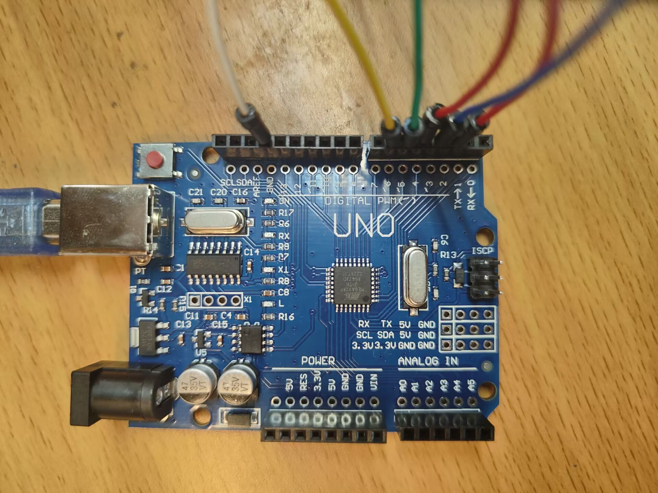

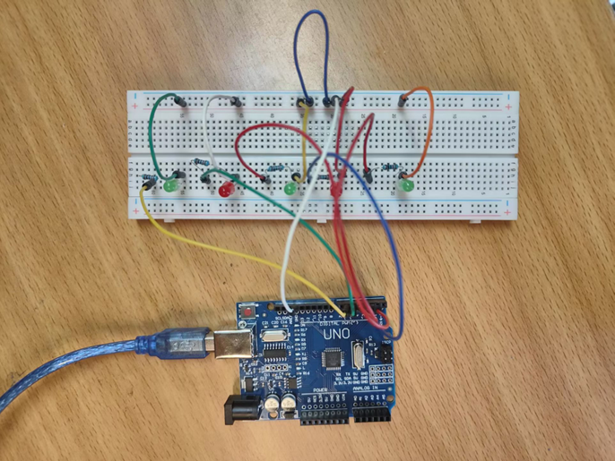

**ii. Basic control of flash**

After the circuit is assembled, we will program on the Arduino board so that all the leds are switched on and off at the same time with a delay of 500ms. This basic control mode is used to test the function of the circuit and ensure that all leds are properly connected.

**iii. Different flash patterns**

Next, we introduce the plan into different flash modes to create unique flash effects. We implemented 4 different flash modes: The first is to flash each decorative light in turn, then turn it off after a delay of 1 second. The second is all the decorative lights flashing together, and then delay 1s and turn off quickly. The third is that each decorative light flashes successively, starting from the last LED and moving to the first LED, each time with a delay of 1s. Then turn off each decorative light in reverse sequence with a delay of 1s. The fourth is to make the adjacent LED pairs in the sequence blink successively, with a delay of 1s to turn off.

## 2.4 Conclusions

In short, through the learning of Arduino programming and circuit assembly, we realized a variety of flash modes, better completed the tasks required by the project, and demonstrated the ability of the Arduino Uno board to control multiple leds to create a variety of flash modes. The final result is a string of decorative functional strobe lights that can be used for a variety of occasions, as shown below.

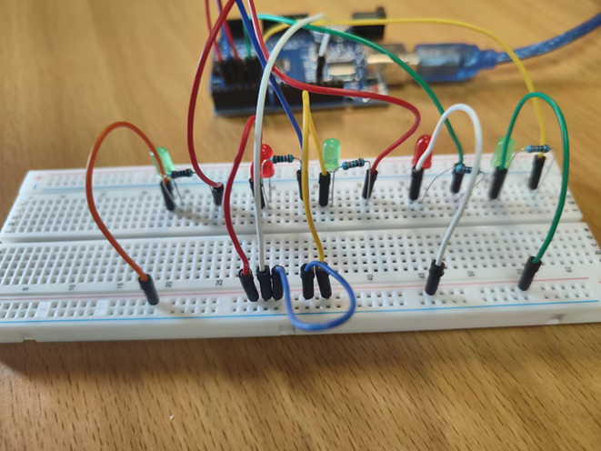

# 3. System Outline

**3.1 Purpose of the system**

To realize the system design of an Arduino-based decorative flash string, the system consists of multiple leds that flash with different patterns and intensities. This system is mainly composed of circuit design and programming design. Since I am responsible for the circuit design of the system and my partner Aron is responsible for the programming design of the system, I will introduce the circuit design of the system in detail below.

**3.2** **System functions**

The main functions of the system are as follows:

1. Voltage applied to multiple leds is controlled by transistors

2. Use resistors to adjust the current flow to led

3. Write Arduino board program to control flash in various modes

4. Use PWM function to achieve different blinking modes

**3.3 Circuit Design**

The circuit design of the system consists of connecting multiple leds in parallel and using transistors to control their voltage. Each LED is connected in series with a resistor to regulate the current. The transistor is like a switch and is controlled by the digital output pins of the Arduino board[3]. The circuit diagram of the system is as follows:

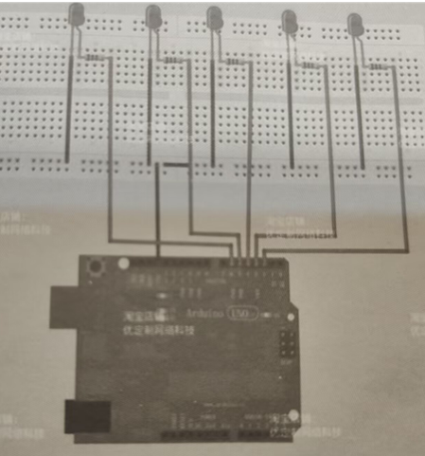

**3.4** **Program Design**

The programming part of the system is completed under the Arduino integrated development environment (IDE)[4]. The code of the system first defines the pin configuration and sets the output mode. The program then cycled through different blinking patterns to control the voltage and duty cycle of the PWM signal.

**Code and code interpretation:**

Top definition variable:

-ledMark : The pin number of the first LED in the sequence,set to 2.

- num: The number of leds in the sequence, set to 5.

In Loop function, different flash modes of LED are controlled through 6 For cycles:

**i**. The first "for" loop turns on each LED in the sequence in turn, then turns it off after a 1-second delay.

**ii**. The second for loop opens all the leds in the sequence at once for a duration of 1 second.

**iii**. The third "for" loop turns off each LED in the sequence in turn, moving from the last LED to the first, with a delay of 0.1 seconds between each LED closing.

**iv**. The fourth "for" loop turns on each LED in the sequence, starting with the last LED and moving towards the first, with a 1 second delay between each LED turning on.

**v**. The fifth "for" cycle turns off each LED in the sequence, starting with the first LED and moving to the last LED, with a 1 second delay between each LED closing.

**vi**. The final "for" loop opens the adjacent led pairs in the sequence and then closes them after a 1 second delay.

In summary, this code creates four flash modes using multiple leds controlled by the Arduino board.

## 4. Results

## 4.1 Project result

The finished product picture of this project is shown below. The decorative light string of this project contains 5 decorative lights. After the correct Arduino program is saved and the USB data cable of the laptop is connected to power supply, the decorative light string can display the flashing effect of 4 different modes.

The first is the continuous flashing mode, where the decorative lights start flashing one after another after a short delay, each flashing lasting 500 milliseconds. The second mode is the Cascade flashing mode, where the decorative lights will light up one by one from the opposite direction after a brief delay in the last flashing of the decorative lights. At the end of the whole glow effect, they will quickly go out, one by one, in the same order. The third mode is mirrored cascade flashing, and the decorative lights mirror the second flashing mode, but the flashing delay is longer. The fourth mode is the random interval mode, in which two decorative lights separated by one decorative light will be lit at the same time in sequence.

Overall, the decorative light series of this project has a variety of flash modes, which are both beautiful and practical.

**5. Conclusion and Contribution**

In short, our string of decorative lights are beautiful in appearance and functional, with a variety of flash modes. It has 4 additional flash modes, including sequential flash, common flash and interval flash. A variety of flash modes can be selected for different practical application scenarios, in addition, the simple assembly mode allows more areas and people to use.

In this project, my contributions mainly include circuit design and implementation, partial programming design and recording of experimental information. Among them, through the circuit design of this project, I have learned and actually applied a lot of new knowledge about Arduino circuit, which not only improves my practical ability, but also enables me to constantly improve the ability of circuit design.

Although the current decorative lamp has satisfied all the exam tasks, it still has a lot of areas that can be improved. In the future, I will continue to learn circuit knowledge and improve this decorative lamp to create more interesting electronic products.

1. **Reference**

[1] Arduino. "Introduction to the Arduino Board." [Online]. Available: https://www.arduino.cc/en/Guide/Board?fro=Tutorial.ArduinoBoard. [Accessed: 01-Nov-2018].

[2] P.A. Garcia-Tudela and J.-A. Marin-Marin, "Use of Arduino in Primary Education: A Systematic Review," Education Sciences, vol. 13, no. 2, p. 134, Mar. 2023. doi: 10.3390/educsci13020134.

[3] F. Corno and L. Mannella, "Security Evaluation of Arduino Projects Developed by Hobbyist IoT Programmers," Sensors (14248220), vol. 23, no. 5, p. 2740, Mar. 2023. doi: 10.3390/s23052740.

[4] K. Vinay et al., "Voice-Controlled Pick and Place Robot Using Arduino Uno," International Journal of Early Childhood Special Education, vol. 14, no. 5, pp. 261-269, Oct. 2022. doi: 10.9756/INTJECSE.V14I5.24.